YACHT CONTROLLER
USER MANUAL

for Brad Connelly

Table of Contents

- Introduction/Overview
- Safety Instructions/Warnings
- Operating Instructions
- Parts List
- Documentation List
- Fault Finding
- Appendix 1

1. INTRODUCTION/OVERVIEW

The manual provides an overview, operating instructions, a parts list, a list of documentation, and fault finding suggestions for the new yacht controller which replaced and old analogue based controller which was no longer operable.

The new yacht controller consists of a small computer or microprocessor board; two motor driver boards; two motors; two chain loops, one to drive the rudder and one to drive the boom; pulleys and guides; a joystick; four end of travel detectors; a 20 amp hour, 12V DC battery; and a mounting frame. In addition there is an on/off switch and a fuse.

The controller joystick allows manipulation of the the rudder and boom positions on the yacht. A separate battery charger is required but is not part of the controller. The frame is located and strapped to the inside the rear of the yacht, with the electronics stored in a metal box which is part of the frame. Te metal box has a removable cover.

The microprocessor scans the joystick and via the motor drivers updates the speed and direction of the rudder and boom motors. The following parameters are adjustable via changing the software:

Parameter | Value
Rudder motor maximum speed | 35% motor maximum physical speed
Boom motor maximum speed | 50% motor maximum physical speed
Acceleration/de-acceleration of the boom and rudder motors from stopped to maximum speed  (these are not independently adjustable) | 1 second
Joystick scan rate | .05 seconds
Centre null zone of the joystick for the motor and rudder | 7% of the full range of the joystick
The time the chain has to move in the opposite direction to move off the end of travel detector. | 1.5 seconds

If the chain reaches an end of travel detector, the motor de-accelerates until stopped. Movement in that direction is suspended until the chain is moved for a specified period of time in the opposite direction and the chain has moved off the end of travel detector.

Each end of travel detectors relies on a fixed reed switch attached to the controller frame and a magnet attached to the chain which activates the reed switch when the magnet is close to the reed switch.
2. SAFETY INSTRUCTIONS/WARNINGS

- The following support crew is RECOMMENDED to use the yacht on the water with the controller:
  - a manned motorised boat to follow the yacht while on the water to provide assistance if required;
  - another person on the yacht to provide assistance if required.

- When servicing the unit chain loops, motors, pulleys or ropes ensure the unit is powered off using switch S1 and the battery is disconnected by unplugging connector C1.

- Only charge the battery when the unit is powered off using switch S1 and the battery is disconnected by unplugging connector C1.

- Do not change the CT UNO microprocessor for a standard Arduino UNO microprocessor as they have different input voltage ranges:
- CT UNO DC 7 15V
- Arduino UNO DC 7 12V recommended

If a standard Arduino UNO is to be installed than a small power supply has to be installed to regulate the voltage below 12 DC.

3. OPERATING INSTRUCTIONS

Operating the unit has been divided into 3 stages: Preparation, On the water and Storage.

Preparation
Steps that must be undertaken before the unit is used:

- Ensure the battery is fully charged. See the instructions on battery charging.

- Ensure the controller is operational by connecting the battery to the controller using connector C1, switching the unit on using Switch S1. When the unit is switched on Switch S1 is illuminated. Then ensure the rudder and boom motor respond to joystick commands and that when activated all four limit switches stop the chain movement in the appropriate direction.

- Always turn off the unit before transporting or moving the yacht.

On The Water - See Safety Instructions

- Leave the unit switched off while unloading or moving the yacht to prevent accidental engagement of the motors.

- Before casting off, ensure the controller is operational by connecting the battery if disconnected, switching the unit on using Switch S1, then ensure the rudder and boom motor respond to joystick commands and that when activated all four limit switches stop the chain movement in the appropriate direction.

- The speed of the motor is dependant on the position of the joystick. The joystick movements are :

To Starboard
To
Port
Loosen
Boom
Tighten
Boom
- When either the rudder or boom chain loop is moving and the chain reaches an end of travel detector, the motor de-accelerates until stopped. Movement in that direction is suspended until the chain is moved in the opposite direction for a specified period of time and the chain has moved off the end of travel detector.

- On completion turn the unit off using Switch S1.

- If at any time while on the water, the yacht is to be used without the controller, then the rudder and boom chain loops have to be disconnected as the motors cannot be turned by hand with the power off because of the internal gearing. The quickest way to do this is:
  - Reach into the inside rear of the yacht and remove the boom chain loop from the sprocket. The chain can be easily lifted off the sprocket because of the stretch in the shock cord.
  - Reach into the inside rear of the yacht, completely undo the turnbuckle in the rudder chain and loop remove the rudder chain loop from the sprocket.

Storage

- With the unit switched off disconnect the battery, using Connector C1.

- Ensure all water is removed from the inside of the boat.

- Ensure all chains are greased to prevent rust.

- Inspect all parts and ropes for wear, looseness or damage and repair and or replace as necessary.

- Put the timber cover over the cockpit and secure a water proof covering over the timber to prevent water entering the cockpit.

Battery Charging

Before charging the battery, ensure switch S1 is off and the controller is disconnected from the battery by unplugging connector C1. NOTE: charging the battery with the controller connected to the battery may damage the microprocessor.
3. PARTS LIST

Where information is available on the parts this has been included in the following table.

Part No. | Item | Image/Description
CPU1 | Microprocessor  Suppliers Description:  Cytron UNO - Arduino UNO Compatible  Suppliers Product Code:  CT-UNO  Supplier:  Cytron Marketplace | 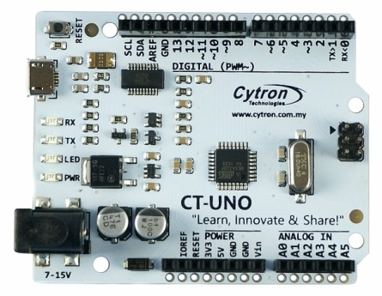
MD1, MD2 | Motor Drivers  Suppliers Description:  Cytron 30A DC Motor Driver  Suppliers Product Code:  MD30C  S  Supplier:  Cytron MarketPlace | 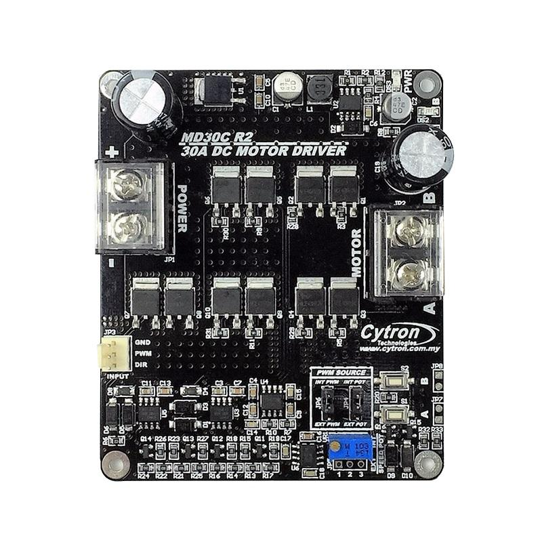
M1 | Rudder Motor | 12V DC motor with:  13 tooth sprocket  Maximum speed of 46 RPM
M2 | Boom Motor | 12V DC motor with:  12 tooth sprocket  Maximum speed of 33 RPM
S1 | On/Off Switch  Suppliers Description:  12V 20A Vehicle Off-Road Rocker Toggle Switch ON/OFF With LED  Supplier:  eBay savemoneyeveryday ( 81169 )
F1 | 30 A Main Fuse | Automotive standard blade fuse
J1 | Joystick  Suppliers Description:  Joystick Potentiometer JH-D202X-R4 10K 2-axis  Sealed PTZ Thermistor  Supplier:  eBay seller mondaynight2013. | 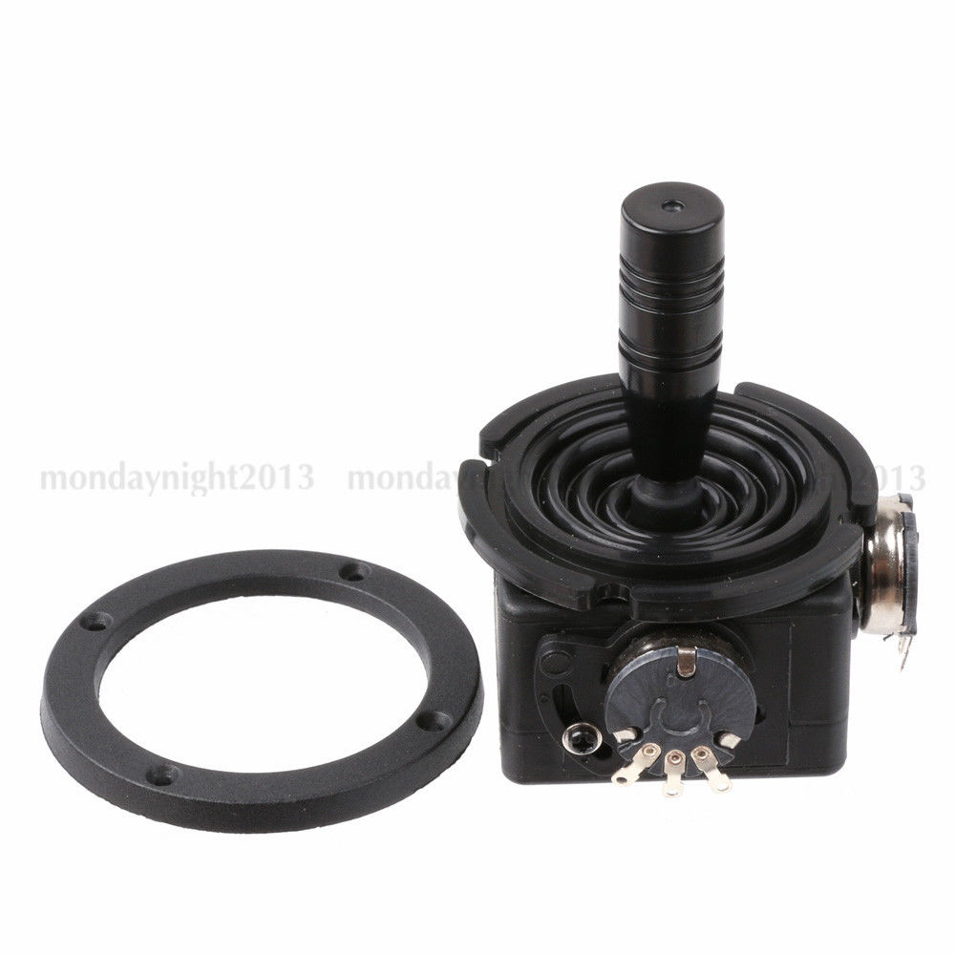
S2, S3, S4, S5 | Reed Switches
M1, M2, | Replaced Magnets  Suppliers Description:  Neodymium Block – 20mm x 6mm x 3mm N52  Suppliers Product Code:  22023B  Suppler:  AMF Magnetics
M3, M4 | Original Magnets
CRL | Chain Rudder Loop | 800mm of standard single speed bike chain size: number 410 1/8" x 1/2”
CBL | Chain Boom Loop | 1,570 mm of standard single speed bike chain size: number 410 1/8" x 1/2".  6mm shock cord.
 | Rope to boom | 6mm multi purpose rope.

4. DOCUMENTATION LIST

The following documentation is available:
Part No./  Description | Documentation Location
CPU1 | User Manual
MD1, MD2 | User manual
Yacht Controller Users Manual V1 | Git Hub Repository:  https://github.com/vonkratzmann/Yacht_V1.git  FileName:  Yacht Circuit Diagram V2.odt
Software | Git Hub Repository:  https://github.com/vonkratzmann/Yacht_V1.git  FileNames:  *.cpp, *.h, *.ino
Circuit Diagram | Git Hub Repository:  https://github.com/vonkratzmann/Yacht_V1.git  FileName:  Yacht Circuit Diagram V1.dsn  Yacht Circuit Diagram V1.png  see Appendix 1
Controller Layout Image | Git Hub Repository:  https://github.com/vonkratzmann/Yacht_V1.git  FileNames:  ??  see Appendix 1
Boom Cable Configuration Images | Git Hub Repository:  https://github.com/vonkratzmann/Yacht_V1.git  FileNames:  BoomCableConfiguration1.jpg  BoomCableConfiguration2.jpg  see Appendix 1

5. FAULT FINDING

Issue | Actions
1. No power. | - Check battery is connected using connector C1.  - Check switch S1 is turned on, S1 should be illuminated when switched on.  - Check fuse F1has not blown. The fuse is rated at 30A. Each motor driver board is rated at 30A continuous output and 80A for 1 second. As the motor driver boards do not have any output over current protection, if there is a fault on the motor then the fuse should blow before there is any damage to the output driver boards.  - Check for loose, broken or unplugged connections or cables.
2. Joystick not operating. | - Check power.  - Cycle the power from on to off to restart the program in the microprocessor.  - With the power off, remove the cover from metal box housing the electronics and remove the electronics. Turn the power back on.  - The microprocessor has a power on led “PWR”, see picture of microprocessor. This should be on, if not check power.  - The microprocessor has a software diagnostic “LED”, see picture of microprocessor. This led continually flashes on for a second, then off for a second. The led indicates the software is running in the microprocessor.  - Check for loose, broken or unplugged connections or cables.  - A laptop running the Arduino development environment and loaded with the source code can be plugged into the microprocessor. Within the code debugging options can be enabled which display on the laptop the position of the joystick and the speed of the motors.
3. Both motors not operating. | - See issues 1 and 2 above.
4. One motor not operating. | - With the power off, remove the cover from metal box housing the electronics and remove the electronics. Turn the power back on.  - Check for loose, broken or unplugged connections or cables.  - The motor driver board has a power on green led “PWR”, see picture of motor driver board. This should be on, if not check power.  - Operate the joystick in both axis, Red LED A turns ON when the output B is low and output A is high. Indicates the current flows from output A to B.  - Operate the joystick in both axis, Red LED B turns ON when the output A is low and output B is high. Indicates the current flows from output B to A.  - Depress Test Button A, when this button is pressed, current flows from output A to B and motor will turn CW (or CCW depending on the connection).  - Depress Test Button B when this button is pressed, current flows from output B to A and motor will turn CCW (or CW depending on the connection).  - To assist with isolation of the fault, the motor can be disconnected from the motor driver board by disconnecting the crimp bullet connectors and connecting the motor via a cable with an inline fuse directly to the battery.
5 End of travel detectors not working. | - Check for loose or lost magnets on the chain.  - With the power off, remove the cover from metal box housing the electronics and remove the electronics. Turn the power back on.  - Check for loose, broken or unplugged connections or cables.  - Activate the reed switches, using a magnet, if operating correctly the diagnostic LED on the microprocessor will flash on and off for a quarter of a second each time the reed switch is activated or de-activated.
6. Cables tangled or broken. | - Ensure the unit is switched off using S1 and the battery is unplugged by disconnecting C1.  - Remove the frame to untangle or replace broken cables.  - The frame is removed by :  - Inside the rear of the yacht remove the boom chain loop from the sprocket. The chain can be easily lifted off the sprocket because of the stretch in the shock cord.  - At the exterior rear of the yacht slide one side off the stainless steel cable off the pulley above the rudder.  - Inside the rear of the yacht remove the rudder chain loop from the sprocket. This can tight, if too tight, loosen the turnbuckle in the chain loop.  - Partially slide the frame out until the rudder chain loop catches on the battery support.  - Completely undo one end of the turnbuckle to allow the frame to fully slide out.  - To remove the frame from the yacht, remove the pulley off the end of the arm on the frame.

APPENDIX 1

BoomCableConfiguration1

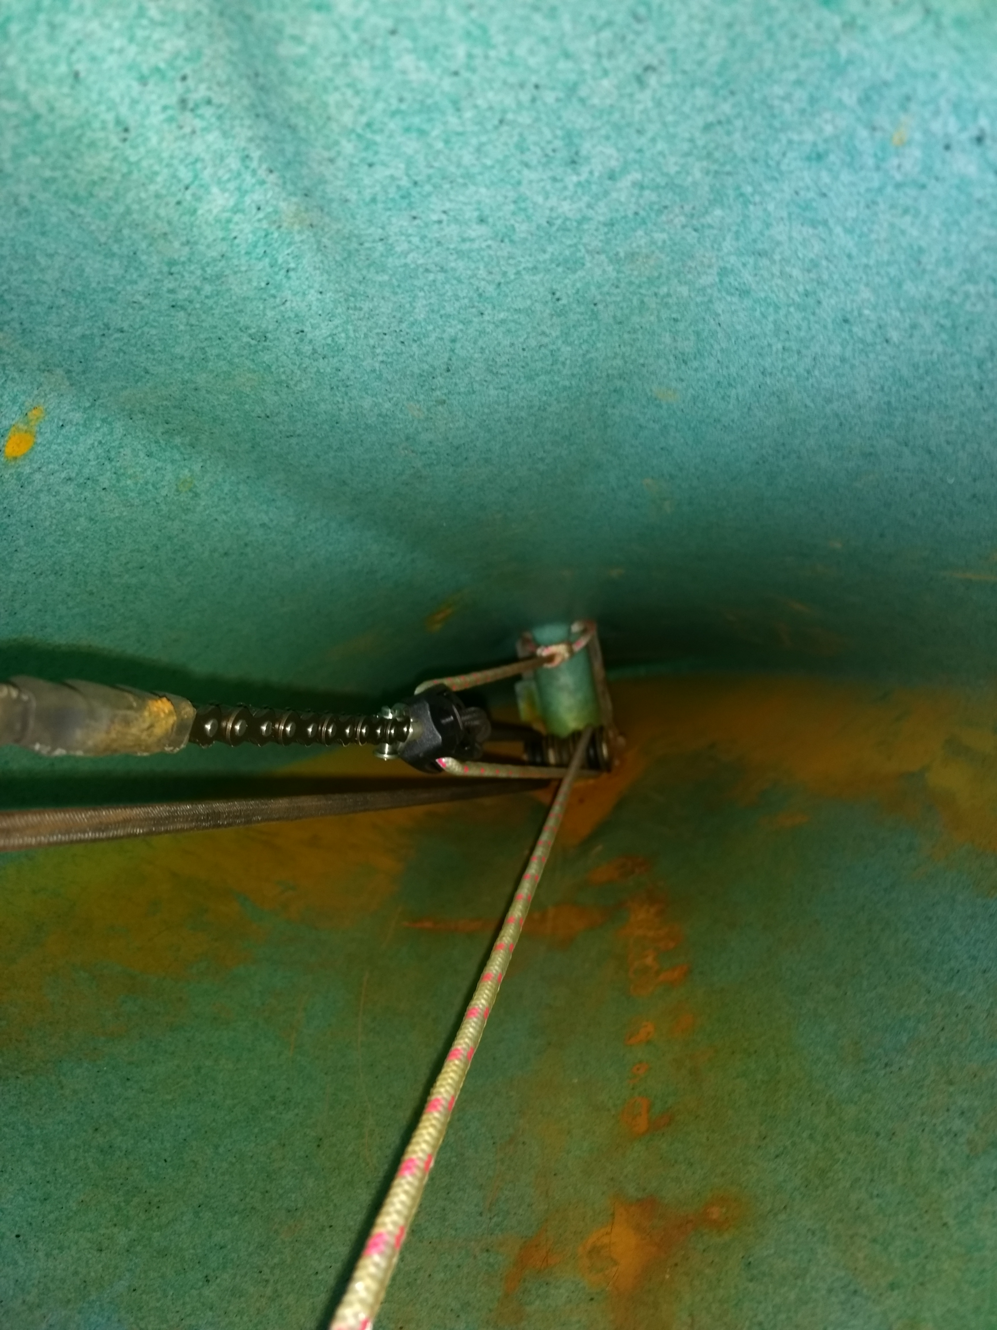

BoomCableConfiguration2

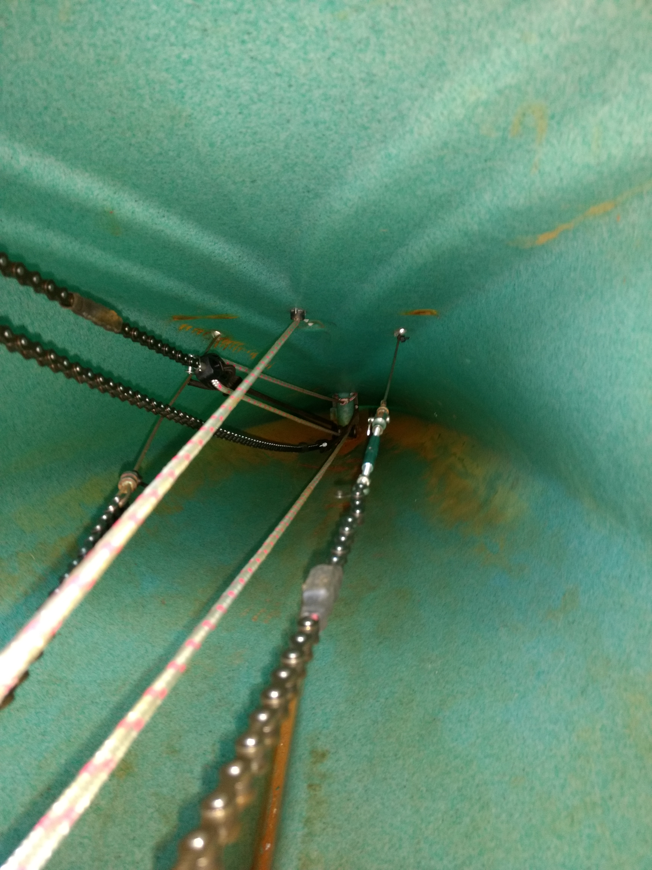

Controller Layout

Circuit Diagram


